# ARCHIVE.ORG - WAYBACK MACHINE

**WAYBACK MACHINE :** It’s a digital archive of world wide web, it allows users to view historical data of web pages offering a snapshot of how website used to look in different point of time.

Example Target site : <http://www.smithbarney.com/>

Snapshot of website in 2000’s

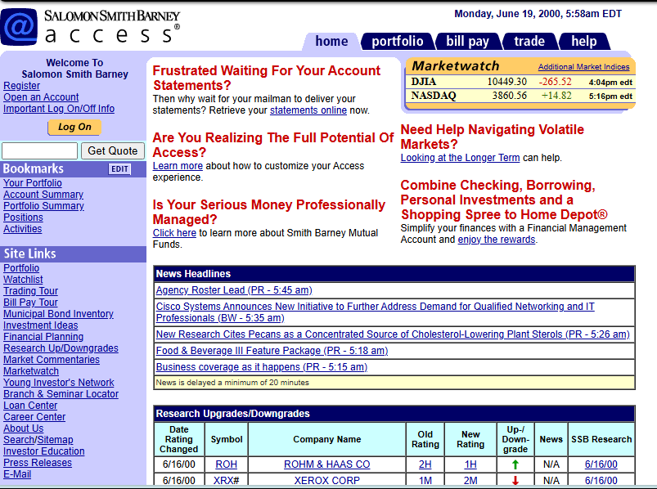

Latest site : login.morganstanleyclientserv.com/ux/

Snapshot of website in 2025



Example Target site : http://www.mozquito.org/

Snapshot of website in 1999’s

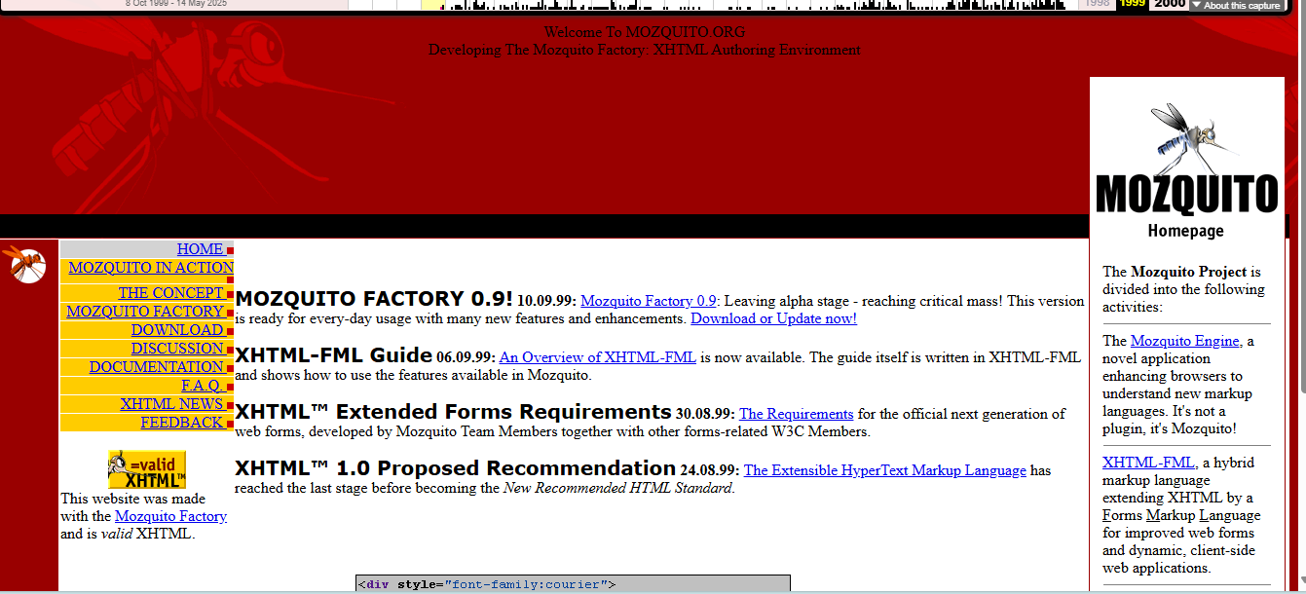

Latest site :https://www.mozquito.org/

Snapshot of website in 2025

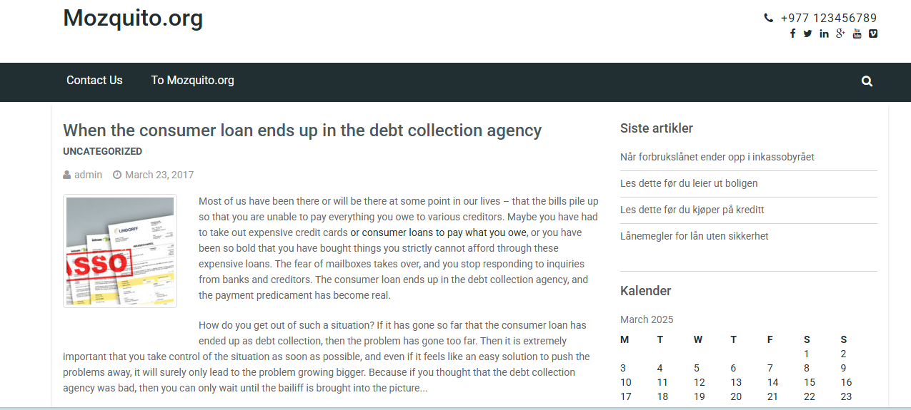

Example Target site : [http://www.imdb.com/](https://www.imdb.com/)

Snapshot of website in 1996’s

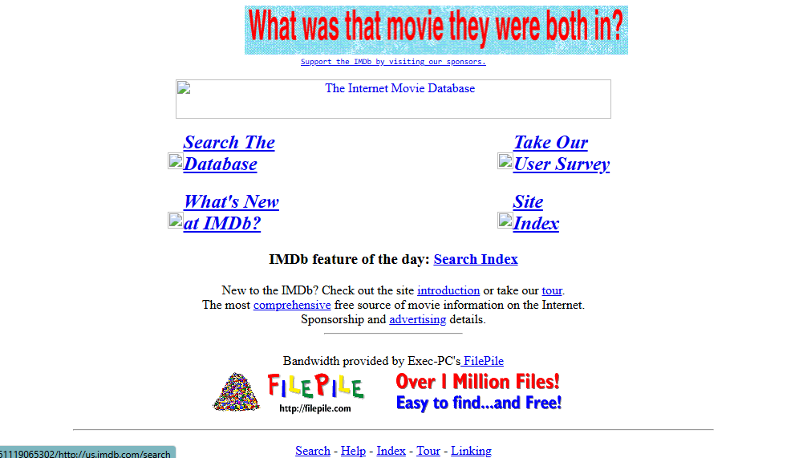

Latest site :<https://www.imdb.com/>

Snapshot of website in 2025

